WTA – Lab Program 2 & 3

-By Harsh R Jain 1BG17CS031

Program 2

<!DOCTYPE html>

<html>

<head>

<title>Page Title</title>

<style>

table, tr, td{

border: solid 1px;

text-align: center;

border-collapse: collapse;

color: black;

background-color: pink;

}

table{

margin: auto;

}

body{

background-color: white;

}

</style>

</head>

<body>

<script>

document.write("<table><tr><th colspan='3'>Squares and cubes of 0 to 10</th></tr>");

document.write("<tr><td>Num</td><td>Square</td><td>Cube</td></tr>");

for(var n=0; n<=10; n++)

{

document.write("<tr><td>" + n + "</td><td>" + n\*n + "</td><td>" + n\*n\*n + "</td></tr>");

}

document.write("</table>");

</script>

</body>

</html>

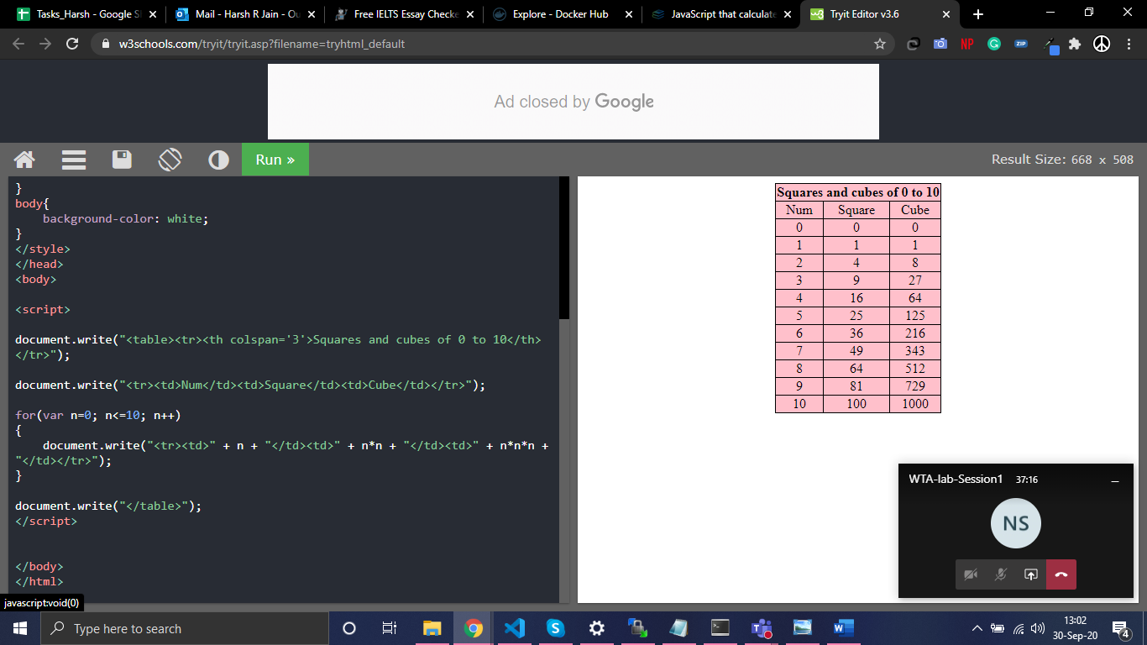

Program 3:

<html>

<head>

<style>

p{

margin: auto;

text-align: center;

}

</style>

</head>

<body onload=fnts()>

<p id="p1" style="font-size:12pt;color=black"> TEXT GROWING </p>

<script>

var grow = true;

function fnts() {

fntsize = document.getElementById("p1").style.fontSize;

document.getElementById("p1").style.color = "red";

ifntsize = parseInt(fntsize);

window.setTimeout(fntGS, 100, ifntsize);

}

function fntGS(ifs) {

if (grow) {

ifs = ifs + 1;

if (ifs <= 50) {

document.getElementById("p1").style.fontSize = ifs + "pt";

}

else {

grow = false;

document.getElementById("p1").style.color = "blue";

document.getElementById("p1").innerHTML = "TEXT SHRINKING";

}

}

else {

ifs = ifs - 1;

if (ifs < 5) {

grow=true;

document.getElementById("p1").style.color = "red";

document.getElementById("p1").innerHTML = "TEXT GROWING";

}

document.getElementById("p1").style.fontSize = ifs + "pt";

}

window.setTimeout(fntGS, 100, ifs);

}

</script>

</body>

</html>

